

Managed Switch
Engineering Requirements Document

Multicast Flow
V1.2

Revision History

Version | Date | Author | Comments
1.0 | 9-Jul, 2025 | Pinaki Sarker | ERD Created
1.1 | 16-Sep-2025 | Pinaki Sarker | Added vlan info in the cli output
1.2 | 14-Nov-2025 | Pinaki Sarker | Added the topology and algorithm on how to figure out the port where a data source is connected for a known multicast group

Contents

1 Abstract 4
2 Scope 4
3 Description 4
3.1 Source IP along with the group IP of a multicast data source 5
3.2 Timeout of IP Multicast Data 6
3.3 Tech Support file 6
3.4 Clear the IP Multicast Table 6
3.5 Support of MainUI, SNMP and openAPI 6
4 Requirement Traceability Matrix 6

Abstract
This ERD (Engineering Requirements Document) is meant to define and describe the requirements to identify the multicast data source in the network by means of CLI/GUI/SNMP/openAPI.

Scope
This requirement is primarily targeted on all Managed Switch series models and shall be supported over stack and MLAG.

Description
The following pictorial representation depicts the requirements. Information of a multicast data source by means of Source IP/MAC and the port where it is connected is the primary requirement. Source information will be used by Engage to populate the multicast traffic flow in the network across the switches.

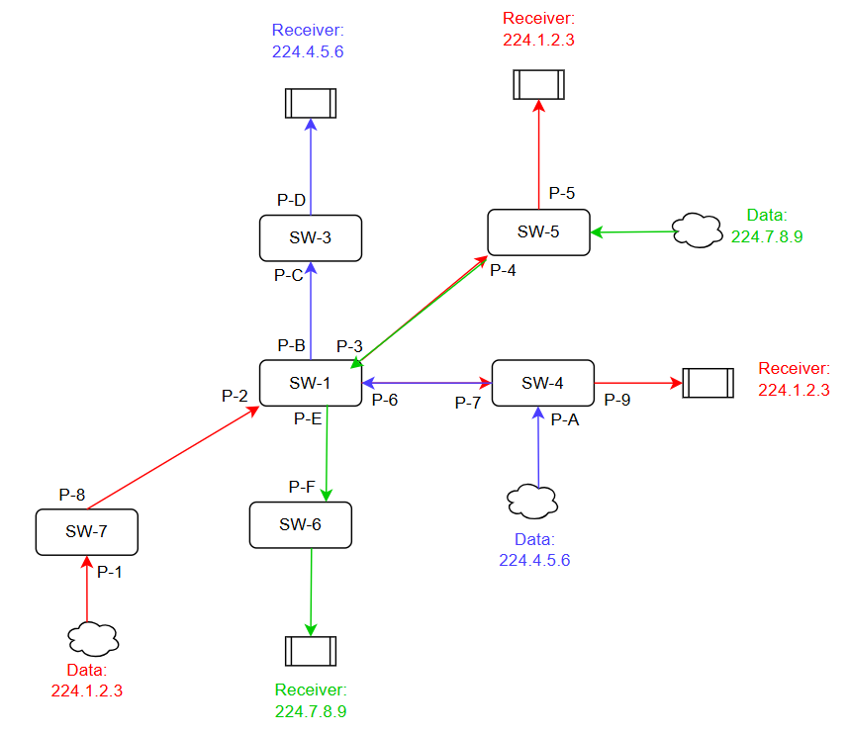

In the above topology, since receivers send the IGMP reports hence the information of receivers viz on which port receivers are connected, MAC address and source IP are always present and shall be retrieved from IGMP Group Table.
Since IGMP Snooping v2 does not deal with source IP/MAC/Port of a data source, hence no straightforward information is available in the switch. Section 3.1 and 3.2 might not be feasible.

Following algorithm will determine the port on which a data source is connected along with the MAC address for which there is a live and active stream.

- Identify the active/known multicast groups for which receivers are interested and send the IGMP reports.
- ‘show igmpsnooping group’ command will display the active/known multicast groups, Source IP/MAC and the corresponding port number where receivers are connected.
- Apply an ACL using the known multicast IP (taken from the above IGMP Table) and install it on the port.
- Check the interface counters by ‘show interface counters’ to judge which ports to consider installing the ACL. If InMcastPkts gets increased in regular intervals, install the ACL on that very port.
- Check the ACL hit counter and if it gets increased continuously, that’s the port where the data source is connected which is sending the data of given known multicast IP.
- Get the source MAC address from the MAC Table associated to the port
- If ACL hit counter does not get increased, then remove it from the port and apply it to the next port.
- Repeat the above steps for all known multicast IPs present at a given point of time in the IGMP table

A command ‘show igmpsnooping source’ shall display the following information describing the port number where the multicast data source is connected, its source MAC address and the multicast IP for which it is sending data out.

(Switch)#show igmpsnooping source

Total Count............................ 5

L2 Multicast Data Table
Ingress
Source MAC Group IP VLAN Port
----------------- --------------- ---- -------
00:01:01:01:01:01 236.4.0.2 1 1/0/1
- 236.4.0.4 2 Lag 1
00:01:01:01:01:03 236.4.0.5 1 2/0/2
- 236.4.0.6 10 Lag 2
- 236.4.0.7 100 Lag 3

If LLDP table shows that a NETGEAR switch is connected to a port-x, and by using above algorithm, a data source is found to be connected on port-x, then Source MAC shall be ignored in the ‘show igmpsnooping source’ table.

Source IP along with the group IP of a multicast data source
On a pure L2 multicast environment where igmp snooping (igmp+) operates to forward multicast data to the interested ports (where subscribers are connected), there is no information of the source IP of the data source is available.

The following command shall display the source IP, group IP, ingress port, timeout and total count. The aforesaid information of any multicast data packet except the IGMP protocol packets shall be displayed as depicted below.

(M4250-10G2F-PoE+)#show igmpsnooping source

Total Count............................ 235

L2 Multicast Data Table
Ingress
Source IP/MAC Group IP VLAN Port
--------------------------- --------------- ------------- -------
10.30.2.2/00:01:01:01:01:01 236.4.0.2 1 1/0/1
10.30.4.4/00:01:01:01:01:02 236.4.0.4 2 Lag 1
10.30.5.5/00:01:01:01:01:03 236.4.0.5 1 2/0/2
10.30.6.6/00:01:01:01:01:04 236.4.0.6 10 Lag 2
10.30.7.7/00:01:01:01:01:05 236.4.0.7 100 Lag 3

Timeout of IP Multicast Data
This ensures that the table reflects only active multicast sources and prevents stale data from persisting due to unrelated network activity. An entry in the L2 Multicast Data Table shall be purged under the following conditions:
- MAC Aging: If the corresponding MAC address is aged out from the MAC Address Table, the associated multicast entry shall be removed.
- Multicast Data Inactivity: If no multicast data packets are received from a source within the configured MAC Age out interval, the entry will be deleted—even if the source continues to respond to ping, DHCP, or other non-multicast traffic.

Tech Support file
Tech Support file shall contain the command output.

Clear the IP Multicast Table
‘clear igmpsnooping source’ command shall flush the table.

Support of MainUI, SNMP and openAPI
There shall be options in MainUI, SNMP and openAPI to display/fetch the L2 Multicast Data Table. OpenAPI and MainUI for this feature are must and SNMP is optional.

Requirement Traceability Matrix

